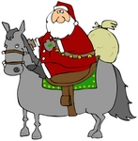

***Rebecca Hurt***

***Cordially Invites Your Horse Crazy Kid To***

# ***“Christmas Horse Ride & Picnic”***

***December 21***

***9:00 a.m. to 2:00 p.m.***

***3318 Viggo Rd.***

***Beeville, TX 78102***

**Please bring a “sack lunch”**

***Please R.S.V.P. by December 10 to   
Rebecca Hurt at  
rebeccahurtr7@yahoo.com or   
call (830)-965-5804***